
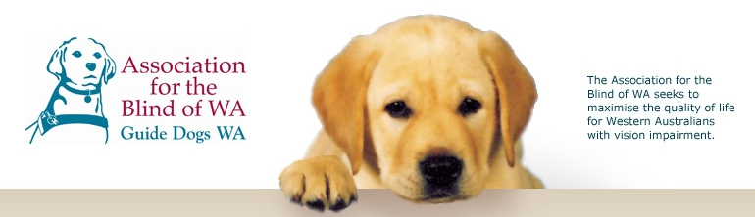

Module 3 - Guide Dogs

This Module addresses both the scientific aspects of animal behaviour and the social relationship between a Guide Dog and an owner. The Module incorporates cross curricula outcomes based on coordination and safety in relation to the way in which a Guide Dog leads their owner and the obstacles the Guide Dog contends with on behalf of the owner.


The following information has been drawn from the Western Australian Curriculum Framework Document and associated Curriculum Guidelines to help teachers place the module in context.

SCIENCE LEARNING AREA STATEMENTS

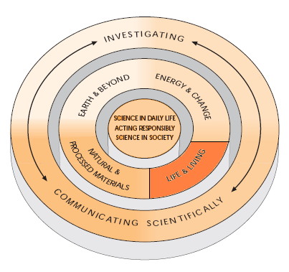
LIFE AND LIVING
Students understand the relationship between structure and function in living things and use that as a basis for understanding life-maintaining processes.

….Students understand their own biology and that of other living things, and recognise the interdependence of life….

…....They know about the effects of disease and how to maintain a healthy lifestyle….

Students can describe how organisms grow and reproduce, and understand how they change over generations.

…..They understand the concept of life cycle and describe some examples for plants and animals….

….They link reproduction with the inheritance of characteristics, by, for example, recognizing that living things grow to resemble their parents…..

…They differentiate between learned and inherited characteristics

HEALTH AND PHYSICAL EDUCATION
LEARNING AREA STATEMENTS

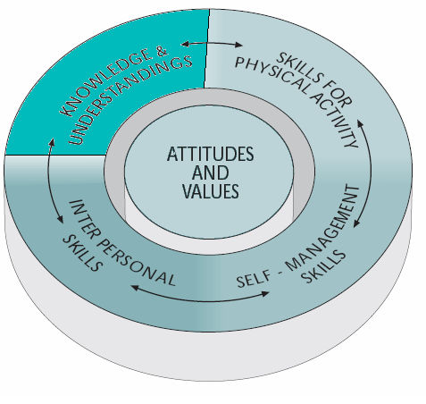
KNOWLEDGE &UNDERSTANDINGS

……..Students know and understand health and physical activity concepts that enable informed decisions for healthy, active lifestyles…..

…..Through knowledge and understandings of key concepts, students are informed and take a critical perspective on health and physical activity issues within family, school, community and work settings…..

…..They know and understand, for example, vital concepts related to growth and development…..personal safety.

ATTITUDES AND VALUES

….Students exhibit attitudes and values that promote personal, family and community health, and participation in physical activity….

…..Students recognise and value, safe and supportive environments…..

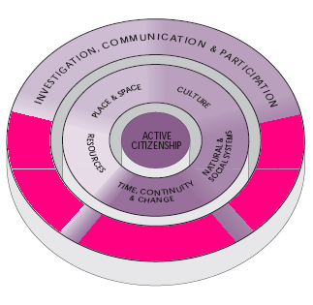
SOCIETY AND ENVIRONMENT

INVESTIGATION, COMMUNICATION AND PARTICIPATION

….Students investigate the ways in which people interact with each other and with their environments in order to make informed decisions and implement relevant social action…..

…..Students investigate aspects of time, place, culture, resources and systems to understand and act on important issues in their social and environmental world. In these investigations, they use skills of critical inquiry and ethical decision making in order to become better-informed, active citizens….

TIME, CONTINUITY AND CHANGE
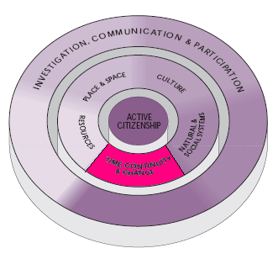
Students understand that peoples’ actions and values are shaped by their understanding and interpretation of the past.

…...Students recognise that by studying people and events of the past, they can better understand the present and make informed judgments about the future….

….They realize that people’s ideas and values are influenced by the actions and values of those who have come before them….

…..Students can, for example, identify significant activities and events in their personal and family life or in their local community over recent generations; trace the impact and contribution of a group or individual on a community or society; and explore the impact of technological and economic developments…..

